Iowa State University

Lab 01: 4G LTE Network Emulation and Throughput Testing Utilizing ARA



Before starting this lab, familiarize yourself with the basics of 4G network infrastructure by visiting [A Beginners Guide to Mobil Communication Infrastructure](https://www.packetcoders.io/a-beginners-guide-to-mobile-wireless-communication-infrastructure/) and reading the section regarding 4G networks. To understand the platform that you will be using read about the ARA sandbox [ARA Sandbox Service](https://arawireless.readthedocs.io/en/latest/ara_technical_manual/sandbox_service.html). The primary hardware used for this lab will be USRP B210 Software Defined Radios (SDRs). For those new to Software Defined Radios, additional resources on SDR fundamentals can be found at [Fundamentals of SDRs](https://5g-prototype.readthedocs.io/en/latest/module_4_fundamentals/index.html).

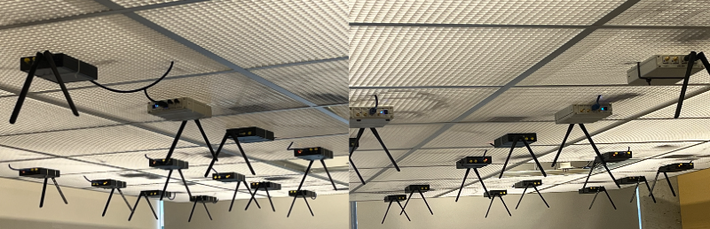

In this lab we will use container images that include **srsRAN**, an open-source software suite for 4G LTE mobile communication. srsRAN provides a complete 4G LTE software radio stack, including the Evolved Packet Core (EPC), eNodeB (eNB), and User Equipment (UE) components, allowing for the simulation and testing of 4G LTE networks. srsRAN is widely used in both academic and industry research for developing and experimenting with 4G and 5G technologies. You will likely need to reference the [srsRAN documentation](https://docs.srsran.com/projects/4g/en/latest/) throughout this lab

Objectives:

1. Successfully set up an emulated 4G network and simulate wireless data traffic between the UE and eNB.
2. Conduct a throughput test on the emulated network and analyze performance.

Learning objectives:

1. Gain an understanding of the key components of a 4G network and their responsibilities.
2. Gain an understanding of communication mechanisms in wireless networks between User Equipment(UE) and Base Stations(eNB), to then further explore potential security vulnerabilities
3. Define metrics that can affect the throughput of a network.

Estimated time to complete this lab: 1 – 1.5 hours.

This lab must be completed in a single sitting because the containers do not persist data once deleted. The lease by default is reserved for 2 hours, but this can be manually increased to a maximum of 5 hours.

To sign up for ARA’s Jumpbox (allowing you to SSH into the VMs), click on your username (ISU email) at the top right of the project page, and select Upload Public Key. On the following page, you will be able to upload a public key file for an SSH key. Take note of your Jumpbox username on this page. Please do this as soon as possible as it may take the ARA team some time to process this. For more information on ARA’s Jumpbox service you can visit [ARA Jumpbox Service](https://arawireless.readthedocs.io/en/latest/getting_started/ara_portal_extras.html#ara-jumpbox)

Once you have signed up for ARA’s jumpbox make sure that you have the RSA private key associated with the public key that you’ve uploaded via the Google Form.

Contents

1) Log on to the ARA portal. 4

2) Reserve two sandbox hosts. 5

3) Create two containers. 11

4) Connect to containers using jumpbox. 16

5) Starting the EPC and eNB 21

6) Starting the UE 23

7) Running the throughput test 23

8) create new UE 27

9) Deleting Leases 27

# Log on to the ARA portal.

* 1. Using your school credentials, log in at [ARA log-in portal](https://portal.arawireless.org/auth/login/?next=/project/leases/).

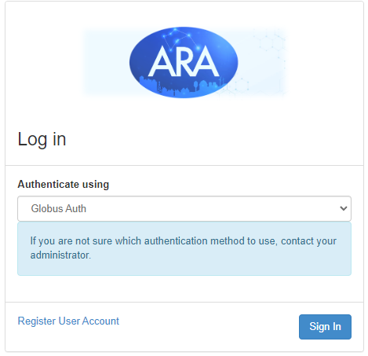

* 1. Search for “Iowa State University” in the search bar and press continue to be redirected to your ISU single sign-on.

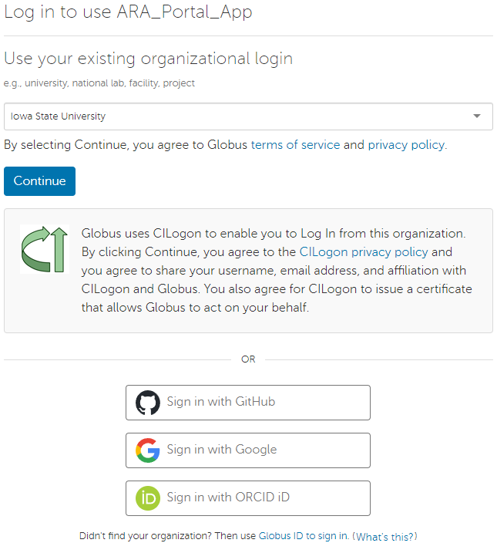

* 1. After you have successfully logged in, you will be navigated to the project page on the ARA wireless portal.

# Reserve two sandbox hosts.

* 1. Go to [ARA Sandbox Service](https://arawireless.readthedocs.io/en/latest/ara_technical_manual/sandbox_service.html) and pick two machines. Any two machines in a cluster like those in the image below are a good choice. For future examples, Sandbox-Host 006 and Sandbox-Host 009 will be used.

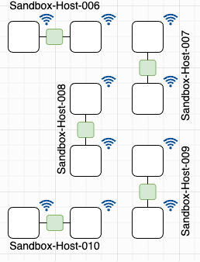

* 1. On the ARA portal, navigate to Reservations → Leases → Host Calendar

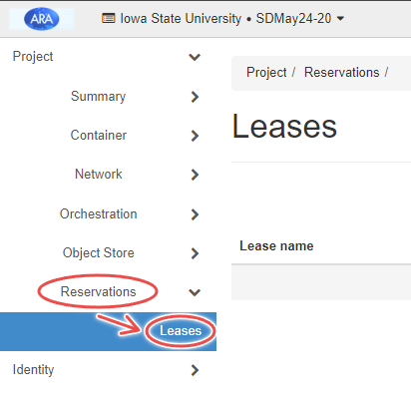 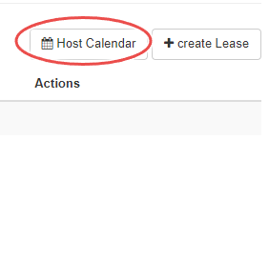

* 1. Ensure the hosts you chose are free to reserve. The image below shows Sandbox-Host-006 and 009 are available. Sandbox-Host 003 is currently reserved see reservation details by hovering your mouse over the colored block.

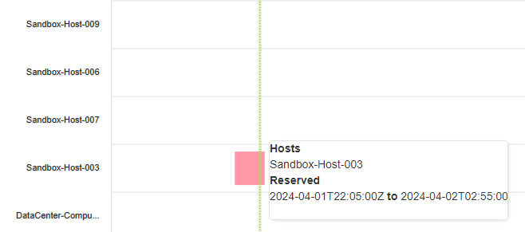

* 1. Return to the leases page and use the “create Lease” button to create the leases for your selected hosts.

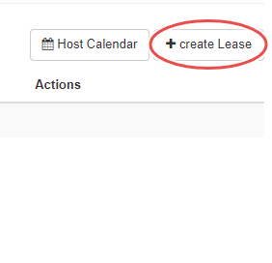

* 1. You can choose a lease name. However, using eNBLease as the lease name is recommended to make things less confusing moving forward. The start and end date can be left blank for a default reservation of 2 hours, which should be sufficient. If you feel like you would need additional time, you can enter in your start and end date, to request for a maximum of 5 hours of resource allocation. Make sure you set the right time zone by navigating to Settings -> Time zone, and setting it to the time zone you plan to enter into the start and end date.

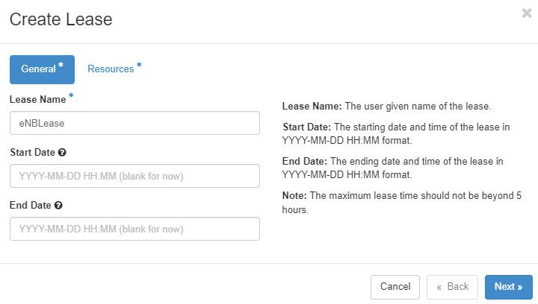

* 1. Use the Site dropdown menu and select Sandbox. The Resource Type should be AraRAN. The Device Type should be Host. For the Device ID of your chosen host Sandbox-Host-xxx, use the three-digit number which is in the place of the “xxx”. For example, I will use Sandbox-Host-006, so the Device ID will be 006:

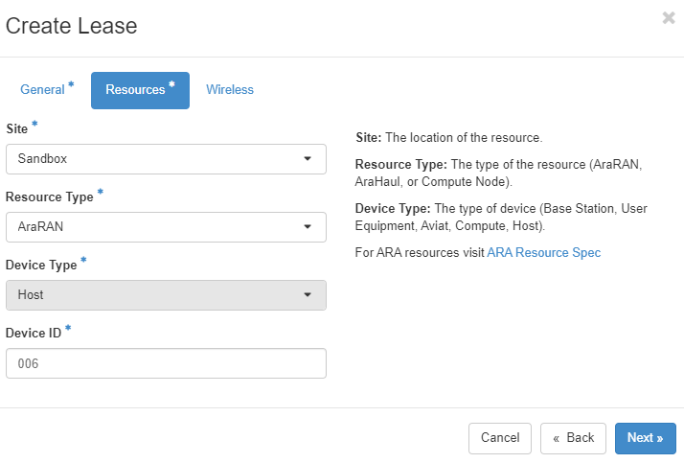

* 1. Leave the wireless section of the lease blank and click create lease.

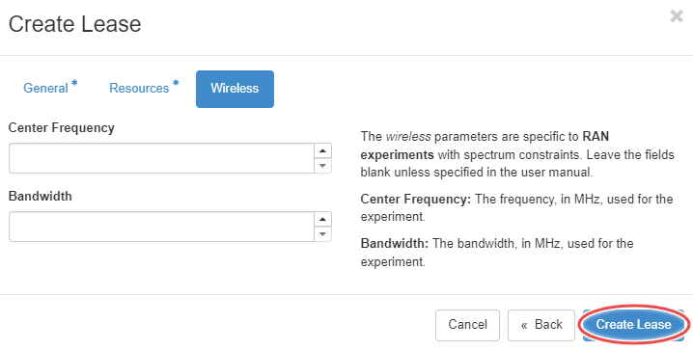

* 1. If done correctly with an available host the following messages will appear at the top right of the screen.

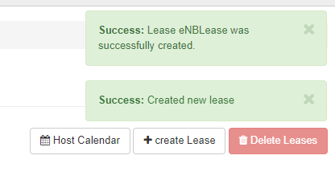

* 1. Do the same for the second lease using your other available host. Using the lease name UELease is recommended to avoid confusion later. For Example, I use Sandbox-Host-009

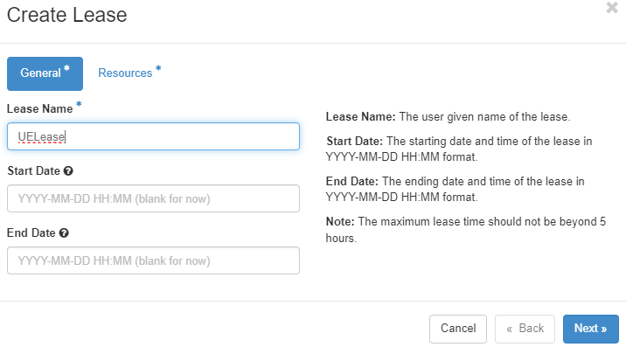

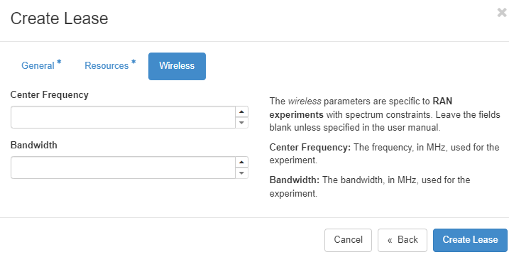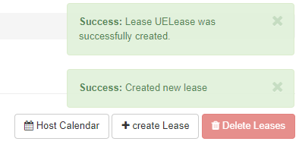

* 1. Provide a screenshot of both of the successfully created hosts’ lease details in your lab report. To see lease details click on the blue lease name.

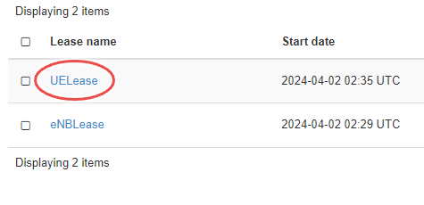

# Create two containers.

With the resources allocated, it’s now time to spawn two containers, one on each host we have a lease for.

* 1. Navigate to Container → Containers → Create Container.

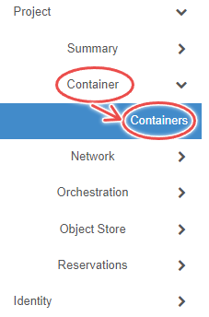 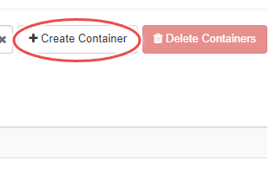

1. For the first container, choose a name. It is recommended to use “eNBContainer” for the name to avoid confusion. Use the docker image arawirelesshub/srsran:srsenb

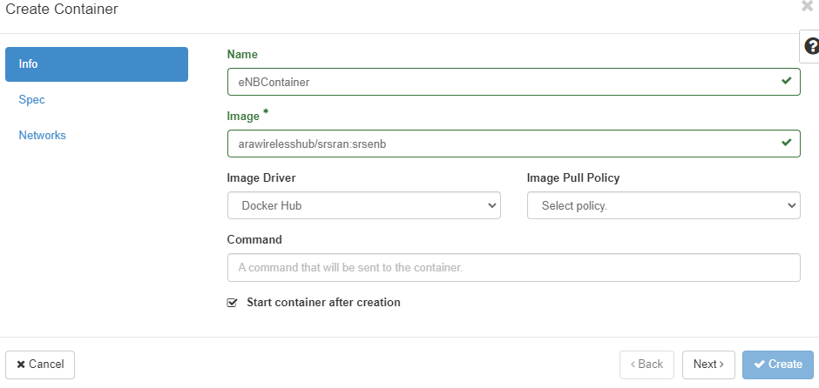

1. Fill in the Spec tab with the following specs.

* **Hostname:** eNB (recommended, but you can choose)
* **CPU:** 6
* **Memory:** 8192
* **Lease Name:** eNBLease (or the name you chose for the first lease).

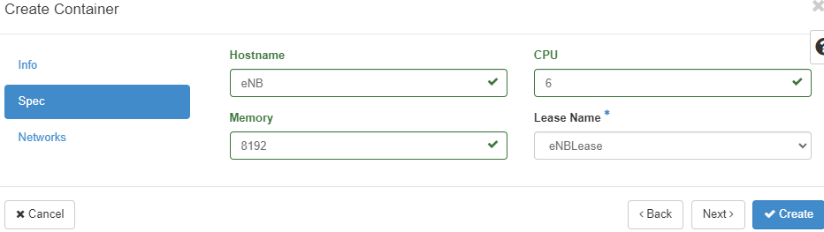

1. Click the up arrow for ARA_Shared_Net in Networks tab, making sure that it moves to the Allocated section, then click create.

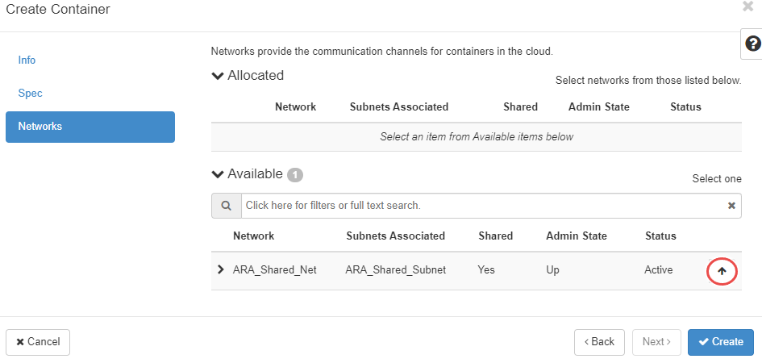

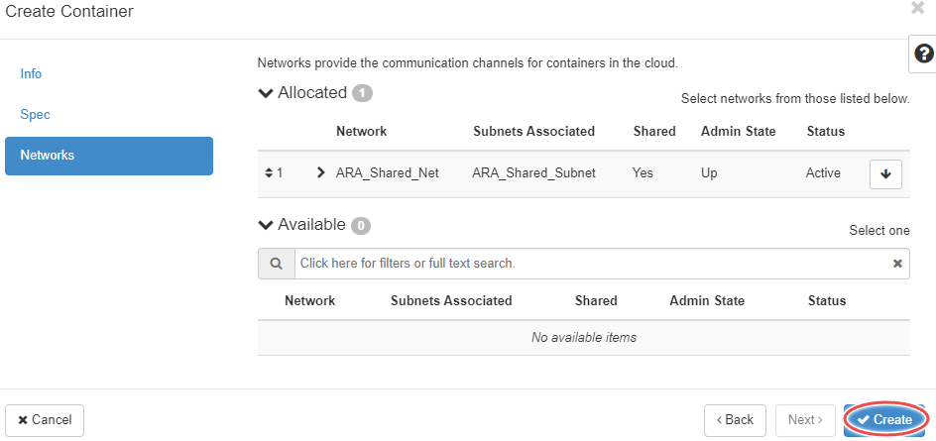

1. If done correctly, a message saying successfully created will appear at the top right. It might take a few seconds for the container to get up and running so while waiting, create the second container.

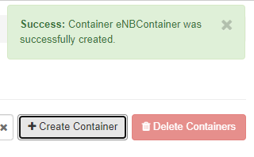

1. For the second container, it is recommended to use the name “UEContainer” and use the image arawirelesshub/srsran:srsue_4g. For the Spec tab, use all the same specs except **Hostname:** UE and **Lease Name:** UELease.

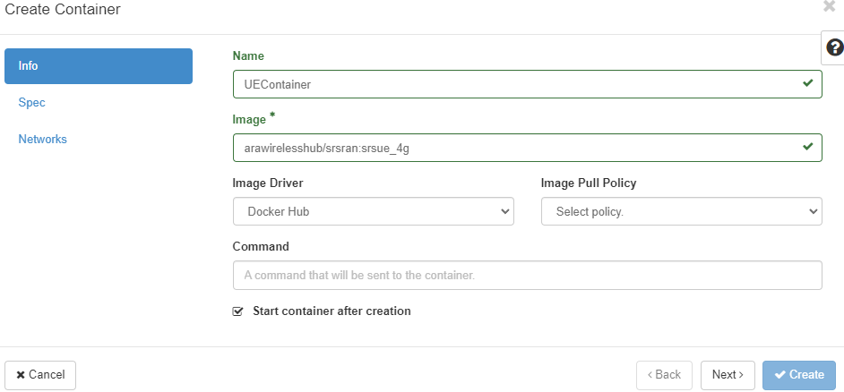

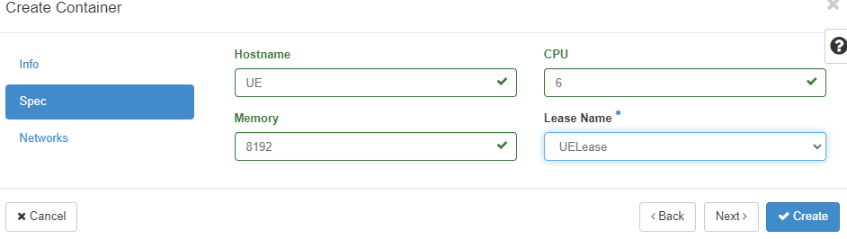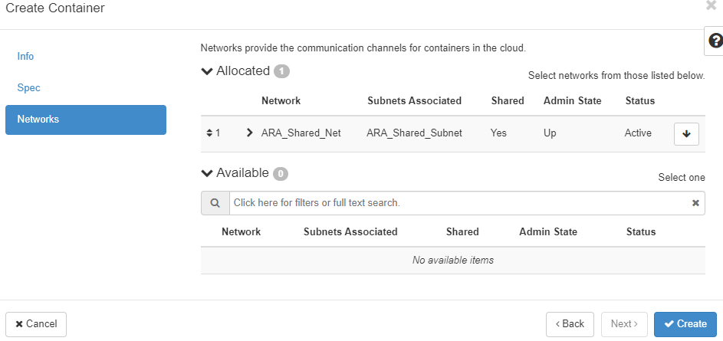

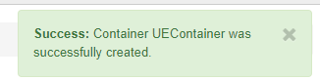

1. Provide screenshots of both of the successfully created containers’ overview tabs. Go to the container overview by clicking on the blue container name.

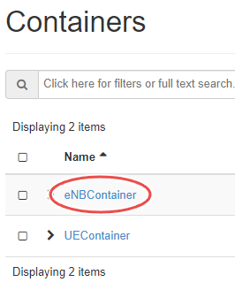

# Connect to containers through the SSH Jumpbox.

* 1. Select the eNBContainer and go to the Console tab.



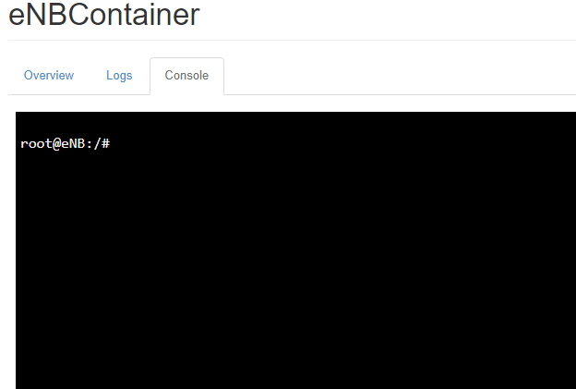

* 1. Run the command passwd using a password you won’t forget. “root” is recommended. Then start the ssh service using the command service ssh start .

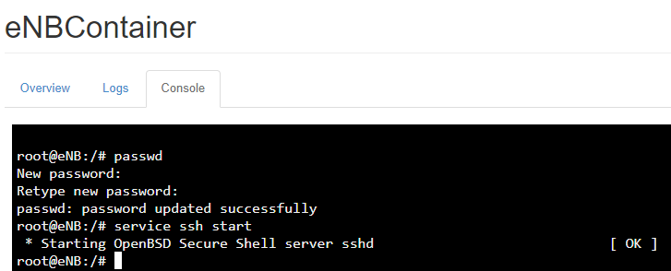

* 1. Do this for the UEContainer as well.

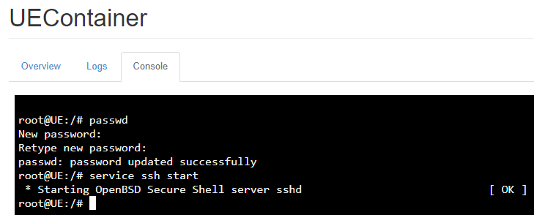

* 1. A black screen with white text

     Description automatically generatedOpen two terminals or command prompt windows and ssh into ARA’s jumpbox **username@jbox.arawireless.org**. Make sure that the RSA private key you used to sign up for ARA’s jumpbox is in the .ssh file on the machine you are using.

Alternatively, make sure that your private key is in the directory you are currently in, and you can run the command ‘**ssh -i private_key** [**username@jbox.arawireless.org**](mailto:username@jbox.arawireless.org)**’.** Additional information on ARA jumpbox can be found [here](https://arawireless.readthedocs.io/en/latest/getting_started/ara_portal_extras.html#ara-jumpbox).



* 1. Go back to overview of eNBContainer. Under “Spec”, a floating IP address will be listed (wait a minute, then refresh if it is not shown). This is the IP address that you will use to ssh from ARA’s Jumpbox to the container, using the username “root” and the password you chose in the parts (b) and (c).

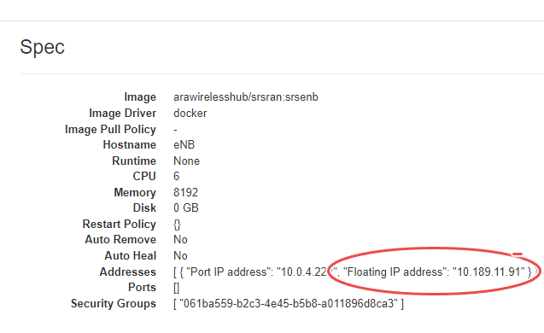

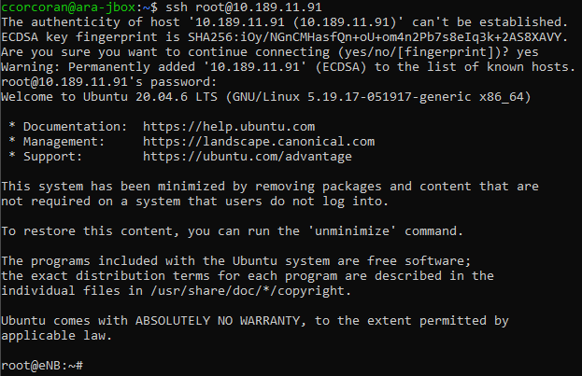

* 1. Establish four total SSH logins, two each to the eNB and UE containers.

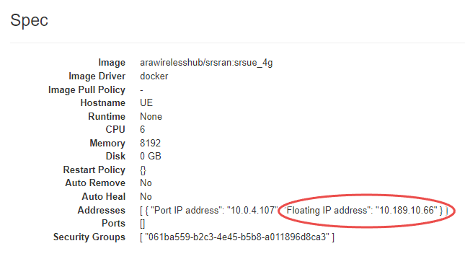

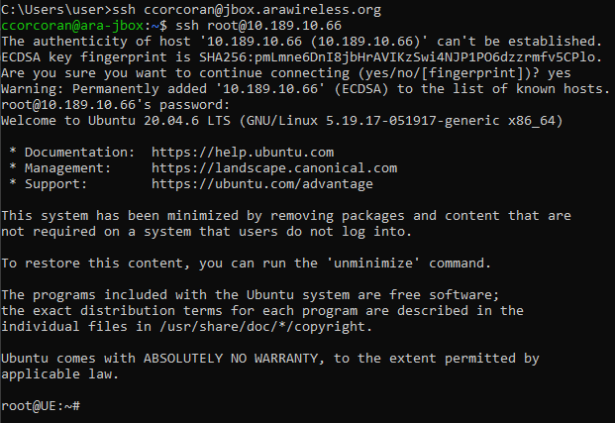

# Starting the EPC and eNB

* 1. In a terminal assigned to the eNBContainer run the command srsepc & to start the EPC in the background, then run the command srsenb.

The Evolved Packet Core(EPC) is a key component of the 4G LTE network architecture, responsible for control functions such as user authentication, session management, and resource allocation.

The ‘srsenb’ command starts the eNB service, that is the hardware component of the LTE network used for direct communication with mobile devices, managing radio communications, and connecting to the EPC. Once the eNB service is initiated, it will start broadcasting and connecting to User Equipment(UE).

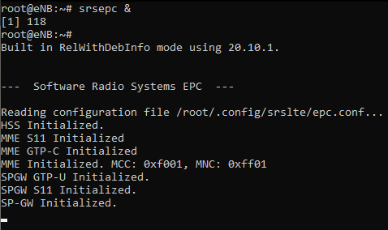

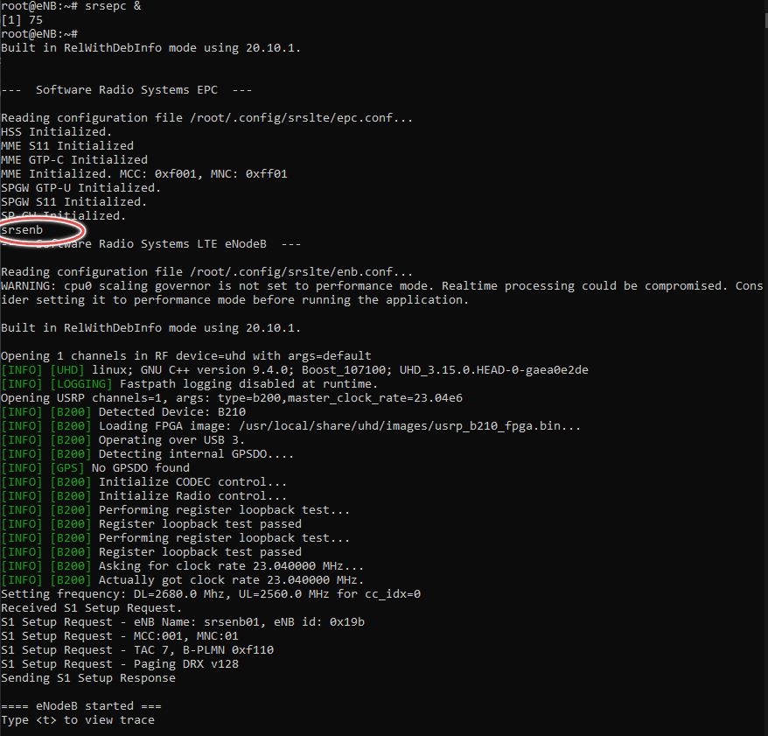

# Starting the UE

* 1. In one of the terminals for the UEContainer, run the command srsue

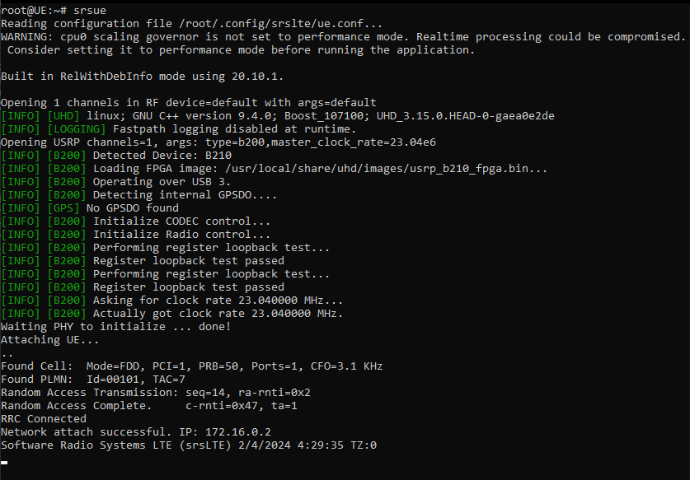

* 1. In the second terminal for UEContainer, run the command ping 172.16.0.1. This will check that you are connected to the core. Provide a screenshot of your successful ping in your lab report.

# Running the throughput test

* 1. In the terminals that are running srsenb and srsue type t and hit enter to start the console trace.

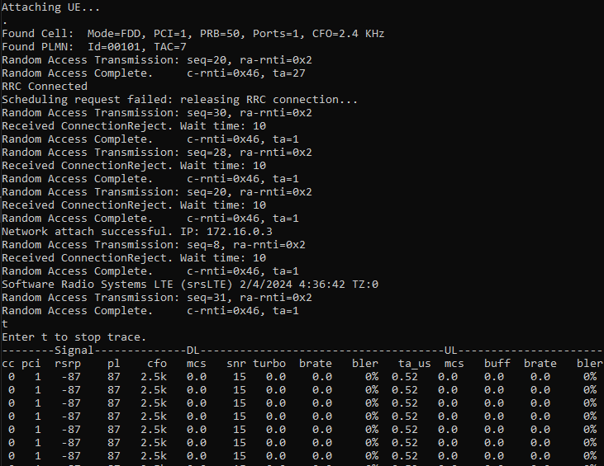

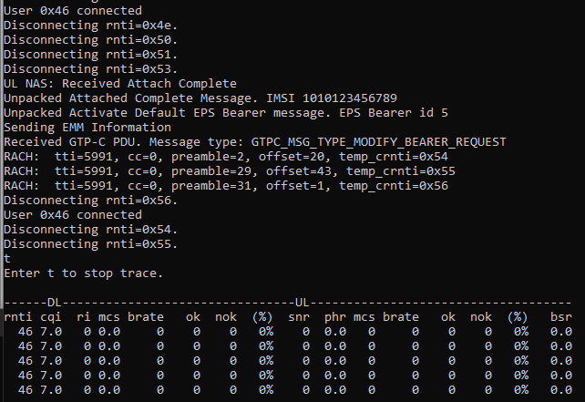

* 1. In the unused terminal for eNBContainer run the command iperf -s -u -i 1

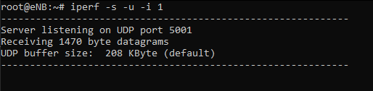

* 1. In the terminal for UEContainer used to run the ping command run the command iperf -c 172.16.0.1 -u -i 1 -b 25M -t 10

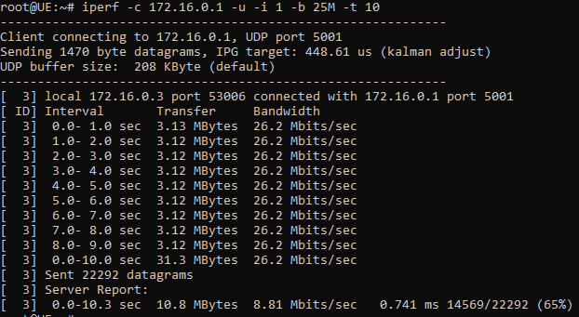

* 1. Provide a screenshot of both console traces in your lab report (only include the output related to the iperf you previously ran). Typing t and hitting enter will stop the console trace. Type t and hit enter again to start it again.
  2. In the lab report, explain what each of the options used for iperf do. Also, define the brate seen in both console traces.
  3. Run the command iperf -c 172.16.0.1 -u -i 1 -b 25M -t 10 but change the value for the -b flag to make a noticeable difference in the brate. Provide a screenshot of the console traces and the value for -b that was used.

# Create a new UE

* 1. To see the effects that the distance between the UE and eNB can have on throughput, find another Sandbox-Host that is further or closer to the eNB. Delete the lease for the current UE, make a new one, and rerun the experiment. The figure above illustrates the location of the Sandbox-Host machine to aid you with your decision to pick a UE further from or closer to your current one.
  2. Describe the changes you observed in your lab report and provide screenshots to support your claims based on change in throughput and so on.

# Deleting Leases

* 1. Navigate to Reservations → Leases and use the box next to Lease name to select both leases, then click Delete Leases.

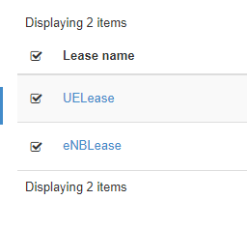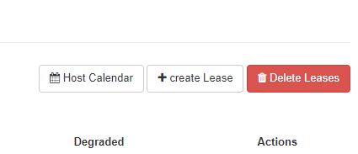

* 1. Provide a screenshot of the empty Leases page in your lab report.